**EEB ASSIGNMENT-1**

**Name:** Ishika Devare **Class:** D15A

Aim: Identify minimum 3 unsuccessful startups with the reason behind it.

Theory:

1. **Doc Talk**

Industry- Health Tech

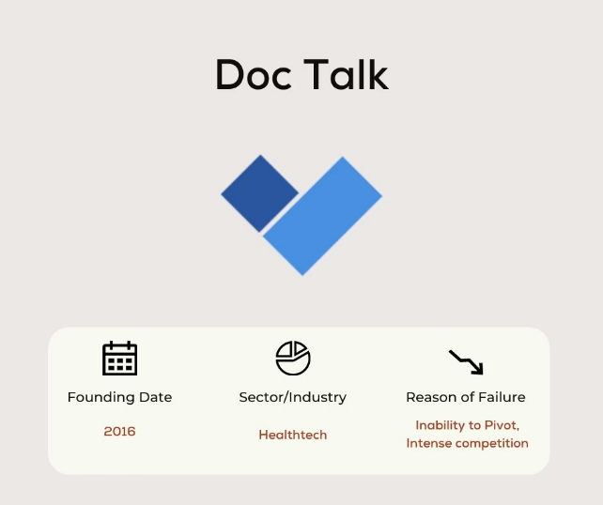

DocTalk helped customers send messages to doctor, store medical files, get detailed prescriptions & save money on medications.

The company helped doctors write digital prescriptions & provide customized prescription templates. This saved doctor's time and makes operations easier for them by solving patients problems digitally.

**Why did Doc Talk failed?**

Their planned transition (pivot) from a communications platform between doctors and patients into the EMR business didn’t yield the acceleration.

Their new EMR solution costed much more than their communication software. And is being sold to doctors.

Other applications like Practo, Mfine, Lybrate were also providing the service of electronic medical records and communication along with their original services.

DocTalk was only providing communication services before the pivot that matched up to other health tech applications. Because of which Doc talk EMR offering lack differentiation from its competitors.

1. **Shopo**

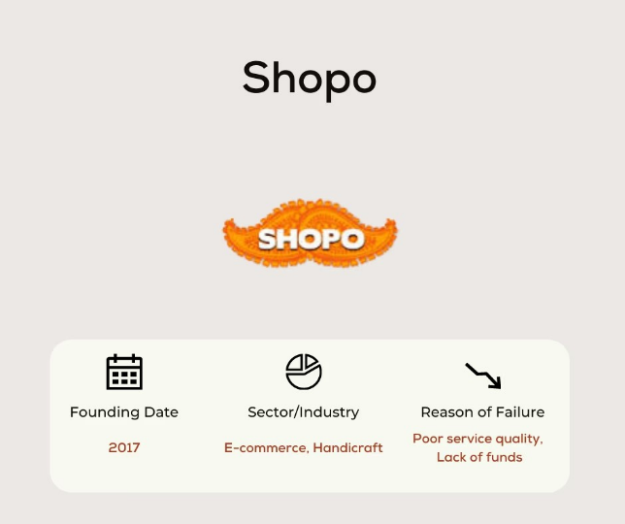

Shopo provides a platform to buy contemporary and traditional Indian designer and handmade stuff.

The startup was founded by Theyagarajan as a zero-commission platform for all small sellers or buyers from across all over India where buyer and seller could freely chat, buy, and sell.

Snapdeal acquired Shopo in May 2013 but relaunched it in 2015. In the same year, Snapdeal announced the investment of $100 Mn in Shopo over a period of two years.

**Why did Shopo failed?**

A huge number of the buyers and sellers were not satisfied with Shopo’s operation and management.

Poor delivery system, no customer care support, product quality was not up to the mark, problems in refunds.

More investments in marketing & operations than actual revenue.

The Shopo service was shut down in the wake of cutting costs and conserving cash by Snapdeal who itself was making huge losses.

1. **GrocShop**

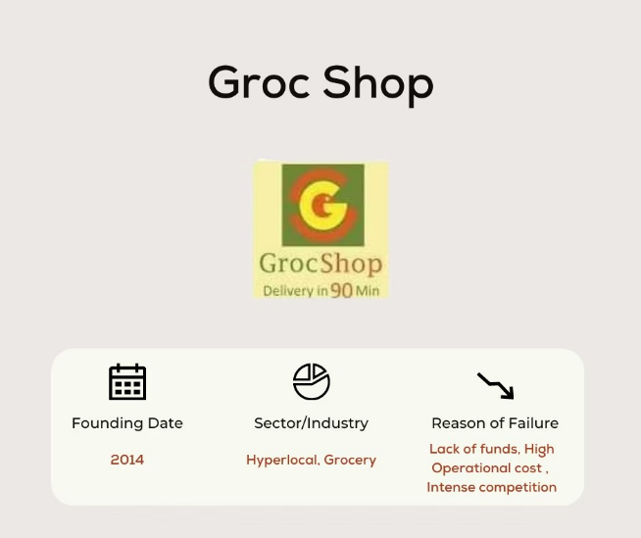

GrocShop was an online hybrid retail platform, completely focused on ensuring shopping for daily essentials & grocery brands. The

The customer can shop either from the comfort of their homes/offices or on-the-go and get orders delivered in minimum hours.

GrocShop was selected for Microsoft's startup programme, BizSpark, which provides startups free software, support and visibility for three years.

In May 2015, GrocShop was among the 16 startups which were selected for the Google Launchpad programme.

Even the company pivoted to an asset-light model and laid off 45 people in the process. It also started outsourcing logistics to Roadrunnr and Grab.

In spite all these notable recognition and efforts to make business model work, the company shut down its operations in 2016.

**Why did GrocShop failed?**

The company could not bear high logistics and customer acquisitions costs and diminishing margins.

Outsourcing of operational businesses incurred huge costs.

With decreasing money flow and no sign of fresh funding led to company into huge cash crunch.

Grocshop were late into the market where other companies had established customers and posed stiff competition.

1. **App Surfer**

Industry- IT Software/Service

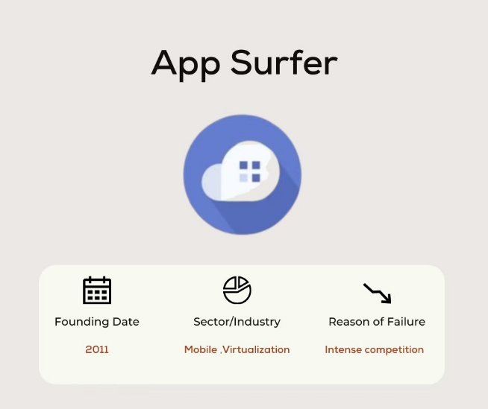

AppSurfer offered tools for developers to demo their apps from the web itself, without installing. These demos can be embedded on blogs, product pages, press releases etc.

It facilitates to run Android on the cloud and makes it accessible from any device or platform.

**Why did App surfer failed?**

Google launched ‘Instant Apps’, a feature that enabled users to stream apps instead of downloading them.

This launch of a better app with similar features was a killer blow to App Surfer.

**Conclusion:**

Top 10 reasons why all these startups failed-

1. No Market demands
2. Lack of a business model
3. Poor Product
4. Poor Marketing
5. Poor Unit Economics
6. No Financing
7. Intense Competition
8. Ignore the need of Customers
9. Legal challenges
10. Disharmony in the team/ Investors